June 2026

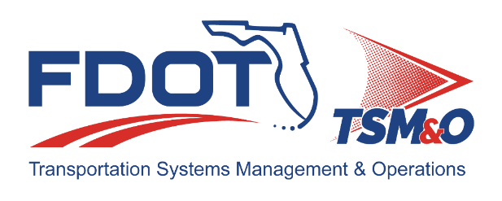
Florida ITS Architecture Support and Maintenance Project
Statewide Update Report
(ARC-IT Version 9.3)

Document Version Control
Author / Action | Submittal Date | Version No.
David Binkley / Draft Document Development | May 21, 2026 | A9.3 05/2026
David Binkley / Finalize Document | June 26, 2026 | A93-2026
Cliff Heise / QA/QC Review | June 26, 2026 | A93-2026

Table of Contents
1.0 Introduction 4
2.0 Description of Changes 4

List of Tables
Table 1. Architecture Updates 5
Table 2. Architecture Maintenance Log (SITSA) 7

Introduction
This Architecture Update Report for the Florida Statewide Intelligent Transportation System (ITS) Architecture (SITSA) identifies the revisions incorporated into the architecture. Revisions made to the SITSA are documented in this report to support Stakeholder input received through Architecture Change Requests as part of the Florida ITS Architecture Support and Maintenance Project.
The Florida ITS Architecture Support and Maintenance Project included the initial major update of the Statewide ITS Architecture (SITSA) and seven RITSAs. Following the major update phase, periodic updates are executed to maintain the architecture content. The FDOT Architecture Team coordinates with the FDOT Project Manager or designee and each applicable District Transportation Systems Management and Operations (TSM&O) Program Engineer or designee for the RITSAs.

Description of Changes
Two maintenance log items were addressed in the update. Table 1 provides descriptions for each change request that was implemented in the architecture update. A log reference number is provided for each change to relate it to the Architecture Maintenance Log that is provided in Appendix A. Each architecture change that is received is added to the maintenance log for tracking and disposition.
The change requests processed with this update were all pointed at updates to the regional planning documents listed on the Resources tab of the architecture website.

Table 1. Architecture Updates
Change | Log Ref # | Actions Taken / Changes Implemented
Stakeholder Name Change - Civil Integrated Management (CIM) is now known as the Office of Operational Technology (OOT). | 204 | - Renamed the stakeholder, which was reflected in the following:  - Stakeholders tab – FDOT Civil Integrated Management (CIM) is now FDOT Office of Operational Technology (OOT)  - Diagrams involving that stakeholder’s elements
Project Name Change - V2X DEP has been renamed to Data Exchange for Operational Technology (DEPOT). | 205 | - Renamed the project, which was reflected in the following:  - Inventory tab – Florida V2X Data Exchange Platform is now Florida Data Exchange for Operational Technology (DEPOT)  - Services tab – service package instances changed  - R&R – roles and responsibilities area for the V2X DEP now refers to DEPOT  - Interfaces – all tables and diagrams updated to reflect DEPOT  - Projects tab – project name updated

Appendix A: Architecture Maintenance Log (SITSA)
The maintenance log in Table 2 provides the SITSA maintenance items considerations for the update.

Table 2. Architecture Maintenance Log (SITSA)
# | Date | Architecture | Source | Contact | Change | Disposition | Recommend Maintenance | Incorporated
204 | 7/21/2025 | SITSA | Change Request | Christine McDonald / FDOT CO OT | Stakeholder Name Change - Civil Integrated Management (CIM) is now known as the Office of Operational Technology (OOT). | Update the appropriate pages to reflect the name change | Yes | Yes
205 | 9/8/2025 | SITSA | Change Request | JoAnna Hand / FDOT CO | Rename: V2X DEP has been renamed to Data Exchange for Operational Technology (DEPOT). | Update the appropriate pages to reflect the name change | Yes | Yes

